**A Literature Survey on IoT Based Safety Gadget for Child Safety Monitoring and Notification**

Team number:PNT2022TMID19685

Team leader: Divyasri M, Team member 1: Abirami P,

Team member 2: Aruna P ,Team member 3 : Dharani S

***Abstract*: In Today's world, the wearable gadgets comprise an increase in market provisioning, wider openings for extemporized authority over security issues for kids in day care and schools. Likewise, women security keeps on being one of the most vital issue that can be addressed today, consequently security of women at working environments, public places is progressively noteworthy issue. This undertaking means to give a total start for secure and wellbeing framework. The thought fills in as confirmation for a wearable gadget with coordinated plan to shorten the need of security issues to women and children. The proposed device is equipped with two modes, adult mode and the child mode that operates accordingly. The sensor empowered gadget gives the real time location and well-being of women and children after accepting signals from sensors. The idea behind this proposed system empowers guardian to locate women and children effortlessly. Pi-camera is used to capture the image in case of emergency. Procurement of raw information from the sensors, trailed by action acknowledgment. Realtime checking of information is accomplished by wireless sensors data to an open source cloud platform [1]. This gadget is modified to consistently screen the subject's parameters and make a move when any perilous circumstance occurs. It is accomplished by detecting the differences in monitored signals, followed by appropriate action taken by means of notifications or alerts. In this manner, the attentiveness of implementation to SMS (short message services) content engaged correspondence medium between the wearable gadget and the guardian, nature for GSM (Global System for Mobile) convenient correspondence is for all intents and purposes present everywhere. The secondary measure used as a piece of this endeavor is the general population show in enveloping of the tyke’s and women 's who could in a brief instant react for their security till the guardian arrives or they could contact the guardian and help find them. To send mail to child’s parents we are using SMTP**

* **(Short Message Transfer Protocol). All these processes are controlled by micro controller and raspberry pi trough internet of things.**

***Keywords*: different types of sensors, buzzer, pi-camera, GSM (global system for mobile), SMS (Short message service)**

* **Introduction**

Internet of things (IOT) is the technology which makes device to sense and control the physical world by making objects smarter and connecting them through an intelligent network. Internet of things uses various concepts, protocols, and technologies. Women and child safety is an extremely huge

worry in a nation like INDIA where women and child are assuming a remarkable job in every single field. India is a peace adoring nation and one of the safe stations for the visitors over the world. Many ladies or children even now feel unsafe to move around outside in our nation due numerous cases of violence against women and child. To make women and child feel safe and secure we have proposed this project. The object and machine can be sensed and controlled remotely though networks. Using IOT we can make things smarter and sensible without using any wires or cables. IOT helps us to use and connect the things wirelessly.

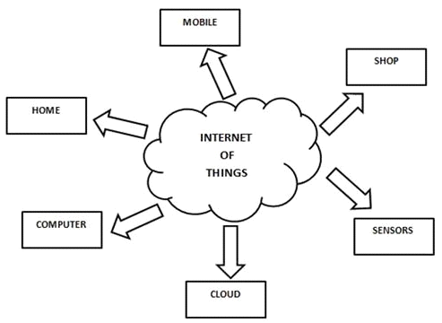

Fig. 1. Internet of things

The fig. 1 shows how the IOT is connecting to unconnected things. The IOT is applicable in many areas some of them are listed below, [2]

* Smart creatures
* Smart connected buildings
* Connected factory
* Connected roadways
* Smart phones

In our project IOT plays a major role which sense the child’s and women’s every activity and alert to guardians. IOT sensor detects the child or women crying, heartbeat, temperature and alerts the guardians through SMS, mail and buzzer for the surrounding people. The camera captures the child and women’s activities when in danger or panic situations. The components and internet of things is controlled by micro controller.

We are using PIC 16F877A micro controller to control over

all system and IOT. RPI3(Raspberry Pi 3) is used to connect to internet of things, sounds, buzzer, mail, SMS, emergency switch, mode switch. All these things are connected to battery to supply the power. RPI is credit card sized computer that plugins into a computer monitor or TV, and uses a standard keyboard and mouse. It is a capable little device that enables people of all ages to explore computing, and to learn how to program in languages like python, C, C++, Java. IOT is used for smart city and smart home to benefit the people. Smart automation method is implemented in this project to get alerts of women and child’s activities and for the purpose of security through IOT developed.

Table 1

Existing versus proposed system

|  |  |  |
| --- | --- | --- |
| Features | Previous System | Proposed System |
| Connectivity | Bluetooth 4.1 | Wi-Fi |
| Hardware | Arduino | Raspberry pi 3 |
| Health Monitoring | Not monitoring | Monitoring present |
| Camera | Not present | Present |
| Power Supply | Battery life low | Enhanced battery life |

* **System design and architecture**

In this busy world parents have no much time to take care of their babies and women have no much time to take care about themselves so, the world is moving towards smart technology through internet of things. In our project we are implementing and developing adults and child security using IoT [6]. Here, we mainly concentrate on temperature, heartbeat, crying, alerting guardians through smart phone using IoT with the help of raspberry Pi. The architecture is shown in fig. 2.

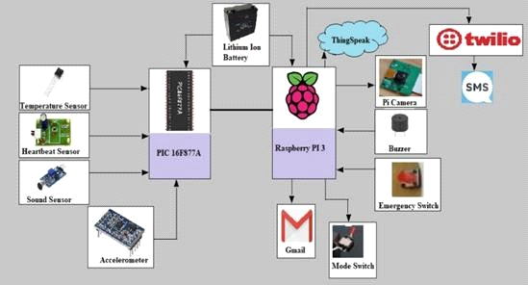

Fig. 2. Architecture diagram

All IoT sensors have analogue ports and they give output as Analog. In order to interface analog values to raspberry Pi Analog to Digital conversion is used. Analog to Digital is a modulation and demodulation process. The different sensors used are Temperature sensor, Heartbeat sensor, Accelerometer and sound sensor. Temperature sensor give values in terms of voltage to IC as 0.35 etc. Heartbeat sensor gives values in terms of pulse PIC microcontroller act as a counter to count Heartbeat rate. Sound sensor gives analog values. Some threshold is set whenever the external value crosses the threshold. It will detect as child/ women is crying. Accelerometer detects position depending on the coordinates. It gives result in form of X, Y and Z values. All these values from various sensors are analog

values, they cannot be interfaced directly with Raspberry pi. So, Analog to Digital microcontroller is used i.e. PIC 16F877A that converts analogue values to digital form. All these values from various sensors are sent to PIC microcontroller that does all A- D conversions. Finally, the converted values/information are sent by serial communication by single wire to Raspberry pi3. Raspberry pi3 collects all data from PIC controller and upload it to server. Server used is thing speak cloud. That could be used to monitor health and safety of child/women. The device has two modes. Child mode and women mode. One can easily set the mode to 0 or 1. 0 is child mode and 1 is women mode. The system has lithium ion battery which is used for power supply with minimum discharge rate. It also has pi camera that is used to capture image of the people in front or the situation. There is an emergency switch which can be pressed manually either by child or women. When an emergency switch is pressed buzzer is activated which is used to alert nearby people so that they can come to the child/women rescue. Depending on the conditions set parents/guardian are notified via SMS and e-mail. SMS through Twilio could be sent along with details of temperature. Heartbeat rate and position of the ward. Email is also sent simultaneously along with the images and other data. Location is also sent in both SMS and e-mail with longitude and latitude values to parent/guardian.

* **Requirements**
* *Hardware requirements*

The various hardware components used in our system are listed below.

* Raspberry Pi 3
* PIC 16F877A
* Heartbeat Sensor
* Temperature Sensor
* Sound Sensor
* Accelerometer
* Emergency Switch
* Buzzer
* Pi Camera
* Battery
* *Raspberry Pi 3*

Raspberry Pi 3 is neither a microchip nor a microcontroller, really it is a solitary board PC which contains a SOC (System On Chip - has multicore processor, GPU, ROM, I/O Peripherals inside it.), DDR RAM memory, Ethernet port, USB have, small scale HDMI on it. Raspberry Pi don't comprise of an inbuilt fixed disk, yet this will utilize a Secure Digital card for start-up and consistent capacity with the Model B+ utilizing a Micro SD.

Coming up next are the ports on the Raspberry Pi board and a portion of their uses. The ports may similarly be used for unexpected purposes in comparison to record underneath.

* *USB:* Mainly utilized for peripherals like Keyboard,

mouse and a Wi-Fi Adapter. A controlled USB center point can be associated and be extended.

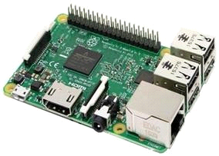

Fig. 3. Raspberry Pi 3

* *HDMI:* This is the High Definition Multimedia Interface [HDMI] and is use to associate with a Display unit like TV or Monitor or some of the time a projector
* *Stereo Audio:* Audio associations utilizing a 3.5 mm jack
* *SD Card:* SD card is utilized as a boot gadget and furthermore relentless capacity. More stockpiling can be connected to the USB
* *Micro USB:* The miniaturized scale USB port is utilized for providing energy to the unit
* *CSI Connector:* CSI [Camera serial Interface] is utilized for associating a camera to the unit
* *Ethernet:* Used for interfacing with a system utilizing a system link
* *DSI Connector:* DSI [ Digital serial Interface] is utilized for associating a LC
* *PIC 16F877A*

The PIC microcontroller PIC16F877A shown in fig. 4 is a standout amongst the most prestigious microcontrollers in the business. This controller is exceptionally helpful to utilize, the coding or programming of this controller is additionally simpler. One of the principle preferences is that it very well may be compose delete whatever number occasions as could be expected under the circumstances since it utilizes FLASH memory innovation. It has a complete number of 40 pins and there are 33 pins for input and output.

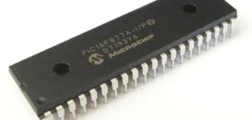

Fig. 4. PIC 16F877A

PIC16F877A discovers its applications in an enormous number of gadgets. It is utilized in remote sensors, security and wellbeing gadgets, home computerization and in numerous modern instruments. The expense of this controller is low and

it’s taking care of is likewise simple. It’s adaptable and can be utilized in zones where microcontrollers have never been utilized as in coprocessor applications and clock capacities. The pin diagram is given below in figure 5.

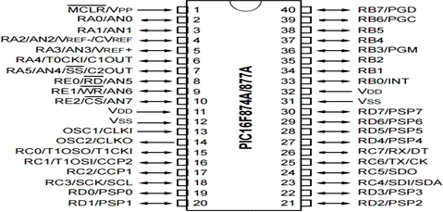

Fig. 5. Pin diagram of 16F877A

As it has been mentioned before, there are 40 pins of this microcontroller IC.[8]

* 4 pins are used for power supply.
* 2 pins are used for crystal oscillator.
* 1 pin is for memory clear.
* Remaining 33 pins are for general purpose input and output.
* There are 5 ports present in this microcontroller.
* Port A: A/D Converter inputs.
* Port B: External interrupt inputs.
* Port C: Serial port, Timer I/O.
* Port D: Parallel slave port.
* Port E: A/D Converter inputs.
* *Heartbeat Sensor*

Heart beat sensor shown in fig. 6 is expected to give automated yield of warmth beat when a finger is determined to it. Exactly when the heart beat locator is working, the beat LED flashes as one with each heartbeat. This mechanized yield can be related with microcontroller authentically to evaluate the Beats Per Minute (BPM) rate. It deals with the rule of light regulation by blood course through finger at every heartbeat.

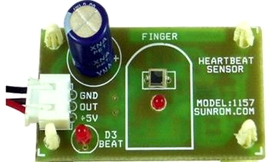

Fig. 6. Heartbeat sensor

* *Temperature sensor*

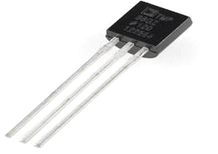

Fig. 7. Temperature sensor

Temperature sensor shown in fig. 7 is utilized to gauge the measure of warmth vitality that permits to distinguish a physical change in temperature from a specific source and changes over the information for a gadget or client.

* *Sound sensor*

The sound sensor module shown in fig. 8 gives a simple method to recognize sound and is commonly utilized for distinguishing sound power. It utilizes a mouthpiece which supplies the contribution to an amplifier, peak detector and buffer. At the point when the sensor recognizes a sound, it forms a yield flag voltage which is sent to a microcontroller then performs essential preparing.

*I. Pi Camera*

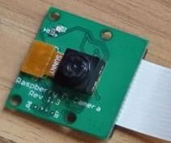The Pi camera module in fig. 11 is a versatile light weight camera that underpins Raspberry Pi. It communicates with Pi utilizing the MIPI camera serial interface convention. It is ordinarily utilized in picture handling, AI or in reconnaissance frameworks. The module comes alongside a strip link, this link must be associated with the CSI (Camera Serial Interface) port of the Pi.

* *Accelerometer*

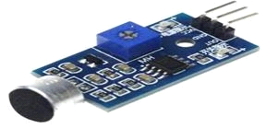Fig. 8. Sound sensor

Fig. 11. Pi- camera

*J. Software requirements*

* *Raspbian Stretch (Operating System)*

Raspbian is a computer operating system built specially for Raspberry pi and the terminal is shown in fig. 12.

* Raspbian stretch is one version of Raspbian.
* It can be used for all versions of Raspberry Pi.

Accelerometer shown in fig. 9 is a transducer that is utilized to measure the physical or quantifiable quickening experienced by an article because of inertial powers and changes over the mechanical movement into an electrical yield. It is characterized as rate of progress of speed regarding time.

* It is a recommended Software.

•

* 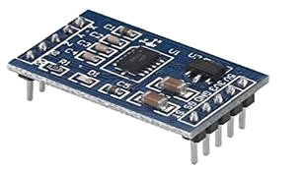*Thing Speak*

Fig. 12. Raspbian pi terminal

*H. Emergency switch*

Fig. 9. Accelerometer

* Thing speak is an internet of Things Platforms to collect and store sensor data in the cloud. Fig. 13 gives as an idea of how data is updated in the cloud and the analysis done in [4].
* Sensor data is sent to the Think speak cloud through the Raspberry Pi.

The switch shown in fig. 10 can be operated manually and automatically. In case of manual, whenever the child/woman feels that they are in danger, they can press the switch so that the buzzer is activated. The automatic operation of the switch happens when the values for temperature, heartbeat, sound and position varies from normal conditions.



Fig. 10. Emergency switch

* The sensor values are stored in Thing speak and can be used for analysis whenever required.
* The guardian or the parent are able to see the temperature, heartbeat values remotely by accessing Think speak account.

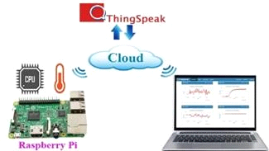

Fig. 13. Sensor data updated to Thing Speak cloud

* *Twilio*

This is a cloud-based application that is used to send and receive Text messages. In fig. 14 the twilio account creation snapshot is given.



Fig. 14. Twilio account snapshot

* *VNC Viewer*

VNC Viewer provides you with remote access to your picked PC. Virtual Network Computing (VNC) is a graphical desktop sharing framework to remotely control another computer [5]. Its aids in making a virtual work area condition. In the event that your host PC is on a similar neighborhood arrange (for example associated with a similar Wi-Fi or Ethernet organize), at that point you can make a direct VNC association with your Raspberry Pi. Fig. 15 is the snapshot of VNC viewer.

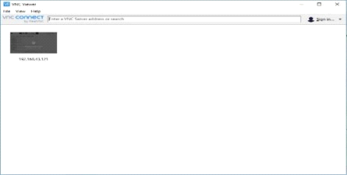

Fig. 15. Virtual screen desktop

* **Expected outcomes**

The platform on which this project will be implemented is the PIC16F77A microcontroller board that performs the conversion of analog signals to digital values. Thus, the controller acts as an analog to digital converter (ADC). The digital values are fed to raspberry pi and the functions of transmitting and receiving SMS, is provided by GSM Module using GSM network. Additional modules employed will provide current location of child and women in terms of latitude and longitude on the google maps that is sent to the guardians via SMS thereby providing maximum accuracy [7]. In the scenario, a lost child or women in danger sends a predefined keyword as SMS to the wearable device which alerts by sending location to designated individual. Additionally, the wearable equipped with distress alarm buzzer which sets to active when the sensors value goes abnormal. Hence the buzzer is louder enough and can be heard by the people nearby from a substantial distance. The proposed wearable device in the form of wrist band will be communicating with the guardians via SMS through GSM which ensures secure and reliable communication link. Customization of wearable can be achieved as per our requirements by reprogramming the PIC system.

The project shall achieve following outcomes:

* With aid of GSM module, current location of child or women can be detected accurately in a short span of time
* Predefined values in the sensors can monitor minimal health condition of child of child in order to take immediate action when the values increase above the threshold.
* To prevent an individual from drooping, we have accelerometer that determines the change in body position of child.
* In Panic situation of child or women the device notifies parent or guardian revealing child’s or women’s distress.

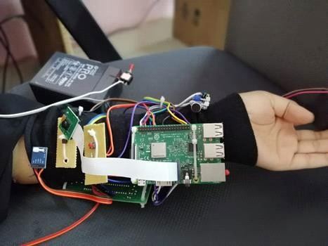

Fig. 16. Expected product

* **Future scope**
* The size of components used in the project can be decreased by a process called micro fabrication, so that it can be transformed into a wristwatch.
* Emergency calling feature can be incorporated wherein women or child under panic circumstances can contact police for assistance.
* SMS can be sent to more than one individual.
* **Conclusion**

To save time and reduce crimes happening we are developing smart child and adult security system which is wearable. This helps guardians to locate their children and women faster and precisely using internet of things. The present work reduces the human effort and particularly mother’s stresses in working times about child. The device affords above scope for modifications for further improvements and operational efficiency, which should make it commercially available and attractive.

**References**

* A. Jatti, M. Kannan, R. M. Alisha, P. Vijayalakshmi and S. Sinha, "Design and development of an IOT based wearable device for the safety and security of women and girl children," *2016 IEEE International Conference on Recent Trends in Electronics, Information & Communication Technology (RTEICT)*, Bangalore, 2016, pp. 1108-1112.
* David Hanes, Gonzalo, Patrick Grosetete, Robert, Barton, Jerome Henry “IoT Fundamental and Networking Technologies, Protocols”.
* “Programmers guide to Internet Mail: SMTP” First edition by John Rhoton.
* L. Mhatre and N. Rai, "Integration between wireless sensor and cloud," *2017 International Conference on I-SMAC (IoT in Social, Mobile, Analytics and Cloud) (I-SMAC)*, Palladam, 2017, pp. 779-782.
* T. Richardson, Q. Stafford-Fraser, K. R. Wood and A. Hopper, "Virtual network computing," in *IEEE Internet Computing*, vol. 2, no. 1, pp. 33- 38, Jan.-Feb. 1998.
* “Digital Parenting: The Best Wearable and new smart baby monitors. The latest smart baby monitors and connected tech for your peace of mind, Tech 2015, [Online] Available: <http://www.wearable.com/parenting/the>- best-wearblesbabies-smart-baby-monitors.
* H. Moustafa, H. Kenn, K. Sayrafian, W. Scanlon and Y. Zhang, "Mobile wearable communications [Guest Editorial]," in *IEEE Wireless Communications*, vol. 22, no. 1, pp. 10-11, February 2015.
* “Working Principle of PIC Microcontroller,” [online] available at: http[s://www.ed](http://www.edgefxkits.com/blog/know-peripheral-interface)gefx[kits.com/blog/know-peripheral-interface](http://www.edgefxkits.com/blog/know-peripheral-interface) controller- pic-architecture-working/